Welcome from the Conference Chair
Dear Colleagues,
It is my great pleasure to welcome you to the 2019 South Carolina Association of Colleges and Employers (SCACE) conference. Our annual conference is a highlight of the year for the organization and we sincerely appreciate your participation.
Also, welcome to Charleston! While here, please take a moment to enjoy our beautiful city and please ask the registration desk or any of the “locals” if there are restaurants, historic sites or landmarks you would like to visit. Many are within walking distance of the Francis Marion hotel.
The continued growth of our organization and this conference is an indication of its high quality and impact. This year I would like to highlight all the new employers registered and thank them all for their attendance. We also had a high volume of program proposals for breakout sessions, and we hope you will attend as many sessions as possible.
Last, I would like to acknowledge the entire SCACE Board and the able leadership of Past-President, Kristin Irwin, without whom, this conference would not be possible.
While the conference promises to be an outstanding experience, we hope that you will also enjoy all that the city of Charleston, SC has to offer. Once again, welcome to SCACE conference ’19 as we Navigate the Changing Tides!
Sincerely,
Jim Allison
College of Charleston

2018-19 Executive Board
Past President President-Elect/Annual Conference Chair Kristin Irwin, Furman University Jim Allison, College of Charleston

Finance Officer Special Events Co-Chair/Member Engagement
Dave Sargent, Clemson University Shanae Giles, University of South Carolina
Communications/Technology Officer Communications/Marketing & PR Emma Waugh, College of Charleston Heather Turner, City Year

Membership Co-Chair Membership Co-Chair Sonya Johnson, Benedict College Dr. Flavia Eldemire, Allen University

Employer at Large Employer at Large
Angie Greenwood, BlueCrossBlueShield Mike Rausch, Fastenal

College at Large College at Large
Chris Lewandowski, University of South Carolina Jessie Cochran, formerly USC-Upstate (Departed April 2019)

In addition to the SCACE Board, this conference could not have been possible without the help of these amazing volunteers & partners:

Erin O’Dea Halford, College of Charleston
Barbie Smrekar, University of South Carolina
Page Tisdale, The Citadel
Emily-Elise Martin, Trident Technical College
Nina Grant, Charleston Southern University
Ferne Redford, College of Charleston
Charlotte Robinson, Furman University
Cory Werkheiser, College of Charleston
Megan Bosch, Benefitfocus
Meredith Cox, The Francis Marion Hotel

THANK YOU!

Get to know our Keynote Speakers!

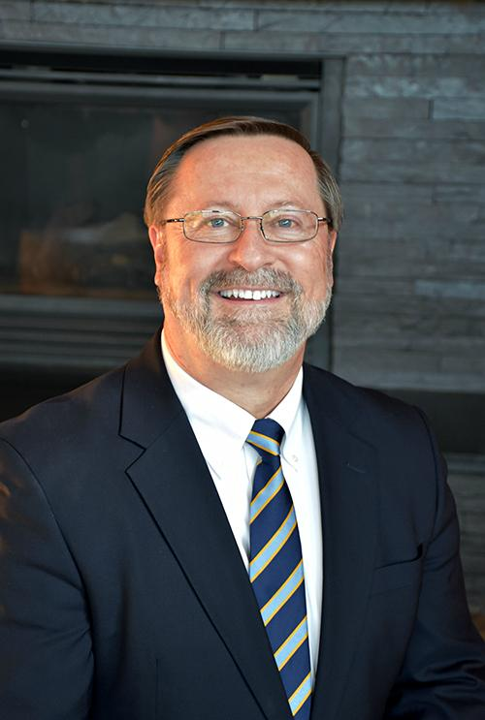
Michael D. True
Senior Associate for Talent Development & Marketing
Career & Professional Development Center | Messiah College
Michael True serves as Senior Associate for Talent Development & Marketing in the Career & Professional Development Center at ﻿Messiah College﻿ in Mechanicsburg, Pennsylvania. He is also president of INTRUEITION, the parent company of InternQube.com. Mike has worked in the field of internships for 29 years and has provided resources to his colleagues, employers, students, and faculty.

For his colleagues he began Internship-Net in 1995, an internet listserv now serving over 1,400 internship professionals throughout North America, Europe, Asia, and Australia. For students participating in internship and co-op experiences he wrote a book, InternQube: Professional Skills for the Workplace, and created a companion website – InternQube.com. For employers he compiled a free booklet entitled "﻿Starting and Maintaining A Quality Internship Program﻿" which is currently being used by hundreds of colleges, universities, employers and chambers of commerce across the United States and internationally. In 2016 he released Faculty Manual: Academic Standards and Best Practices for Internships. His most recent contribution is "Higher Education & Experiential Learning: Select Trends and Future Ideas" in the 2018 publication, International Internships: Mission, Methods & Models (a collection of papers from the Global Internship Conference).
He has been interviewed by the Wall Street Journal, the New York Times, Money Magazine, U.S. News & World Report, Business Week, Newsday, the Chronicle of Higher Education, Inside Higher Ed, as well as other national and regional newspapers and magazines regarding internships. He has served as Chair of the Internship/Co-op Special Interest Group of the ﻿National Society for Experiential Education﻿ and is a certified trainer with the ﻿Cooperative Education and Internship Association﻿.

Mike has been named one of ten Visionary Leaders in a national survey, presented with the Exemplary Leader Award and Higher Education Leader Award by NSEE, the Dean Herman Schneider Award from CEIA, and has received several other honors from various other organizations.

Carla Hickman
Executive Director
EAB
Carla Hickman serves as Executive Director with EAB. She leads EAB’s Enrollment Management Forum, COE Forum, and Market Research division. Carla’s research equips higher education leaders with the insights, data, and resources needed to elevate marketing, recruiting, and program development strategy in service of enrollment and revenue growth goals.
In addition to expertise in enrollment and professional, continuing, and online education, Carla’s research has spanned multiple academic and administrative areas including international education, student success, workforce development, and IT services.
In addition to her time at EAB, Carla served as a business analyst with the Postsecondary Success program at the Bill & Melinda Gates Foundation. In this role, Ms. Hickman supported Completion by Design, a signature investment in scaling student success and organizational excellence across community colleges.
Carla started her career in education as an elementary teacher in New York City and Washington, D.C. She holds an MBA from the Fuqua School of Business at Duke University in marketing strategy and social entrepreneurship. She also holds an MS for Teachers from Pace University and completed her undergraduate studies in political science at Colgate University.
Conference Schedule
Wednesday, May 22
1:00-3:00pm Optional Employer Visitation at Benefitfocus
12:00-5:00pm Conference Check-in Exhibition Space
6:00-7:30pm Presidents’ Reception Gold Ballroom
Thursday, May 23
8:00-9:00am Breakfast Carolina Ballroom
9:00-9:15am Welcome
9:15-10:30am Opening Keynote: “Future Vision: Career Services and Experiential Learning”
Michael True, Senior Associate, Talent Development & Marketing, Career & Professional Development Center, Messiah College.

10:45-11:45am Breakout Session #1
NextGen Career Services – Everything from Zed to Alpha Carolina Ballroom A
Target Audience: Both - College & Employer Partners
Cory Werkheiser, College of Charleston / School of Business Student Success Center

“Career services for GenZ? I’m still trying to figure out these Millennials!”
To paraphrase Winston Churchill, the solution to customizing career services to generational differences and preferences is a riddle wrapped in a mystery inside an enigma. And it’s not going to get any easier because the tides they are a-changin' - Get ready to navigate the next wave: Gen Alpha.
In this interactive session, we will discuss current trends in career services related to Millennials and Generation Z, as well as a critical discussion about the next generation, Alpha (because, well, we ran out of letters), and the opportunities and challenges facing both employers and educators.

Guiding Major EXPLORERS to Their Safe Harbor Carolina Ballroom B
Target Audience: College Partners
Meredith Gerber, College of Charleston
Emma Waugh, College of Charleston

Selecting an academic major is one of the most significant decisions students make in college. They are often overwhelmed by the sea of major and career possibilities. The College of Charleston Career Center offers both one-time Choosing a Major workshops and a 4-week Explore workshop series to help students navigate many of the possibilities. These workshops are opportunities to engage first and second-year students in the career development process through a framework that encourages self-reflection and personalized action steps. Learn about how we market, implement, and assess the two workshop series, and share your major and career exploration ideas!

Employer Outreach: Tips, Tricks, and Best Practices Calhoun Room
Target Audience: Both - College & Employer Partners
Shanae Giles, University of South Carolina
Annie Shealy, University of South Carolina

Ever wondered how employer relations teams conduct their outreach? In this session, we'll share the different types of outreach (i.e. conferences), how the University of South Carolina utilizes Handshake to create leads, and the basics of creating a target list for the year. We're here to learn with you, so attendees are asked to bring their own ideas and experiences to share!

12:00-2:00pm Lunch & Business Meeting Carolina Ballroom

2:15 -3:15pm Breakout Session #2
Internship Award Program: A Budget Model Carolina Ballroom A
Target Audience: Both - College & Employer Partners
Jim Allison, College of Charleston
Erin Halford, College of Charleston
Kristin Wichmann, College of Charleston

The College of Charleston Career Center’s annual Internship Award Program offers a modest stipend for approximately 15 rising sophomores and juniors to pursue summer internship opportunities. This presentation will discuss the program’s funding source, applicant selection criteria, hybrid classroom structure, as well as successes and challenges. Following the presentation, there will be an open discussion to learn how other institutions manage their existing internship programs as well as brainstorm future program ideas. This session is for career centers who have funded programs or are thinking of starting one.

Mentoring - a High Impact Practice that Helps Students Navigate Their Future Carolina Ballroom B
Target Audience: College Partners
Leah Hughes, Clemson University – College of Business
Students who have a mentor in college are 2.2x more likely to be engaged at work after they graduate. Alumni who are connected to the college or university are more likely to give back to their alma mater financially. Learn how a campus-wide initiative at Clemson University is engaging students by connecting them with alumni mentors. By looking at several different mentoring program models, you will gain insight into establishing or advancing your own college mentor network. Resources, best practices and “lessons learned” will be shared.

Social Surge – Navigating the Rogue Waves of Apps and Social Media Platforms for Recruitment, Interviewing, and Hiring Calhoun Room
Target Audience: Both - College & Employer Partners
Cory Werkheiser, College of Charleston / School of Business Student Success Center

“But I already have a LinkedIn account.” That’s a great start – 10 years ago. There’s a tsunami of new apps and technologies all promising to streamline the process of hiring talent. Is it effective? Is it efficient? Is it working? Is it AI? Is there an algorithm? Well, as long as there’s an algorithm, we’ll all be fine…
This interactive session will focus on the latest apps and programs, especially the introduction of artificial intelligence, related to the hiring process.

3:15-3:30pm Break

3:30-4:30pm Employer Showcase Main Hallway
Take advantage of some networking time to get to know the employers at the conference!

Evening Free time in Charleston!
Reference the “Things to do in Charleston” handout if you need some ideas!

Friday, May 24
8:00-9:00am Breakfast
9:00-10:30am Closing Keynote: “Higher Education in the New Learning Economy” Carolina Ballroom
Carla Hickman, Executive Director, EAB

10:45-11:45am Breakout Session #3
Career Readiness: Assessing the Competencies that Today’s Employers Desire Carolina Ballroom A
Target Audience: Both - College & Employer Partners
Randy Bitting, SkillSurvey Inc.
Erin Mullen, University of South Carolina

Is your institution able to clearly measure if your students are career ready? Numerous studies show a wide disconnect between employers and academics perceptions on student competency mastery. The Career Readiness Project, a program launched by SkillSurvey here in Charleston in partnership with the NACE Center for Career Development and Talent Acquisition, offers the first-ever consistent and comparable way to measure against the eight NACE competencies following a student’s participation in internships, co-ops or on-campus jobs. Explore how The University of South Carolina joined 75+ NACE member colleges in Phase 2 and 3 of the project to measure their students’ proficiency using an online method developed by I/O psychologists that obtains feedback from their supervisors and the students themselves on 28 observable behaviors that map to the eight NACE competencies.

Time to Reimagine! Carolina Ballroom B
Target Audience: Both - College & Employer Partners
Kristen McMullen, College of Charleston/School of Business Student Success Center

Inspiration is everywhere if we just look for it. Don't get stuck doing the same old thing over and over again. Attend this session to learn about ways to re-imagine how you deliver services or how you recruit students. Our work can be fun and interesting if we dare to re-imagine it! Where will your inspiration come from?

Career Fairs: A Case Study Calhoun Room
Target Audience: Both - College & Employer Partners
Erin Halford, College of Charleston, Career Center
Kristin Wichmann, College of Charleston, Career Center

From large career weeks to smaller, targeted career fairs, colleges across the country seem to be facing a similar question: as the demand for specialized recruiting programs continues to grow, can traditional career fairs keep up?
Join us as we take a deeper dive into various career fair models and discuss the pros and cons of these models on our campuses. Hear from a small panel of faculty and staff who have implemented innovative career fair models at the College of Charleston. Learn about best practices for collaboration and communication strategies and optimizing program attendance. Participate in a guided discussion about the next wave of campus recruiting and be prepared to share how your campus is navigating these waters (water wings are welcome).
Panelists will include: Dr. Morgan Koerner, Chair of the Department of German and Russian Studies, College of Charleston, Cory Werkheiser, Assistant Director of Career and Professional Development, School of Business, College of Charleston

12:00-1:30pm Lunch & Conference Closing Carolina Ballroom
Breakout Session Presenters
Alphabetical by last name

Jim Allison is the Executive Director for the Career Center. Jim earned his Bachelor’s degree in English from Wake Forest University in North Carolina and a second degree in Psychology from the University of North Carolina at Greensboro. He earned his Master’s in Counseling with a concentration in Student Development in Higher Education. Before joining College of Charleston, Jim served as the Director of the Center for Career Development at Washington College where he was also a pre-law advisor. Jim worked as Associate Director at the University of Evansville in Indiana, where he served as President of the Indiana Association for Employment in Education. In addition, at Elon University, Jim served as an Assistant Professor and Associate Director of the Center for Career Development. He was also the liaison to the Love School of Business at Elon University, specializing in experiential education and student professional development.

Randy Bitting is leading SkillSurvey’s efforts to enable higher education institutions to measure and assess student career readiness leveraging SkillSurvey’s proven HR solution and the eight competencies identified by the member institutions of the National Association of Colleges and Employers. Prior to SkillSurvey, Randy joined Handshake as the first senior member of the early, pre-seed team and played a lead role in helping Handshake grow from 5 to 500+ universities in just three years. Randy pioneered the video interviewing category in 2003 as the founder and CEO of InterviewStream.

Meredith Gerber is the Associate Director for Career Education in the Career Center at the College of Charleston. She earned her master's degree in Counselor Education from Radford University and has been helping college students navigate college and career goals for the last 20 years.

Shanae Giles is the Employer Relationship Manager for companies in the Hospitality, Consumer Packaged Goods, Retail, Sports & Entertainment, Journalism, Advertising, and Public Relations industries. She supports companies in those areas in creating a recruiting strategy for building brand awareness on campus and hiring Gamecocks. When she's not on the job (or even sometimes when she is) you can find her outside hiking, kayaking, and especially doing yoga!

Erin O'Dea Halford is the Employer Relations Manager at College of Charleston Career Center. She received her Master of Education in Counseling and Bachelor of Arts in American Studies from Providence College in Rhode Island. Erin has worked in career services in various capacities including career counseling, internship coordination, and employer relations. The former Internship Coordinator at College of Charleston in 2007, Erin went on to work for The Art Institute of Charleston and Northeastern University in Boston, MA before returning to College of Charleston.

Leah Hughes works with Clemson's College of Business managing career and professional development initiatives. In addition to employer engagement and professionalism trainings, she manages the highly successful Tiger Ties Mentorship Program. She has also been a leader in helping to spread mentoring across the entire campus, with 14 different programs currently in place and more in development. Leah holds a Master of Human Resource Development degree from Clemson University and, most recently, earned certification as a Corporate Etiquette & International Protocol Consultant from the esteemed Protocol School of Washington.

Kristen McMullen has dedicated nearly 20 years of her life to higher education, bolstering various universities’ alumni relations, spearheading career service initiatives and creating programs that connect students with the resources they need to succeed at the likes of the University of Pennsylvania, Penn State University and Duke University. She currently serves as director of the College of Charleston School of Business Student Success Center (SSC). Kristen has identified opportunities to increase student engagement and created new services to further partnerships with faculty and employers. She received a Bachelor of Science degree in health policy and administration from Penn State and is currently pursuing her masters degree.

Erin Mullen is the Assistant Director of Experiential Education for the Career Center at the University of South Carolina. In her role, she manages the Carolina Internship (CIP) and Cooperative Education Programs, facilitates opportunities for job shadowing for students, and provides support to employers hosting opportunities for students. Erin has 12 years of experience working in Career Services and Event Management. She has a Masters in Student Affairs in Higher Education from Indiana University of Pennsylvania (PA) and a Bachelor of Arts in Sociology from the State University of New York.

Annie Shealy is the Employer Relationship Manager for Engineering, Technology, Manufacturing, Transportation & Logistics, and Pharmaceutical industries. She helps employers develop and implement a holistic recruitment strategy and connect to the talented students at UofSC. When she is not on the job, Annie is working towards her MBA with the Moore School of Business or chasing down her wild child pup, Woody, an active Brittany Spaniel.

Emma Waugh is a Career Counselor in the Career Center at the College of Charleston. She earned her master's degree in Anthropology at University of South Carolina and has been helping high school and college students navigate college and career goals for the last 7 years.

Cory Werkheiser is the Assistant Director of Career and Professional Development for the College of Charleston School of Business Student Success Center. With experience in both K-12 and higher education career services, he coordinates with students, employers, and faculty members to provide outstanding internship, employment, and professional development opportunities.

Kristin Wichmann is the Experiential Learning Coordinator at College of Charleston Career Center. She received her Master of Arts in Human Sciences from Hood College and her Bachelor of Science in Elementary Education from Pennsylvania State University. Kristin previously served as the Internship Coordinator for the College of Charleston Department of Political Science and as the Career Center Recruiting Coordinator at Mount St. Mary's University in Maryland.
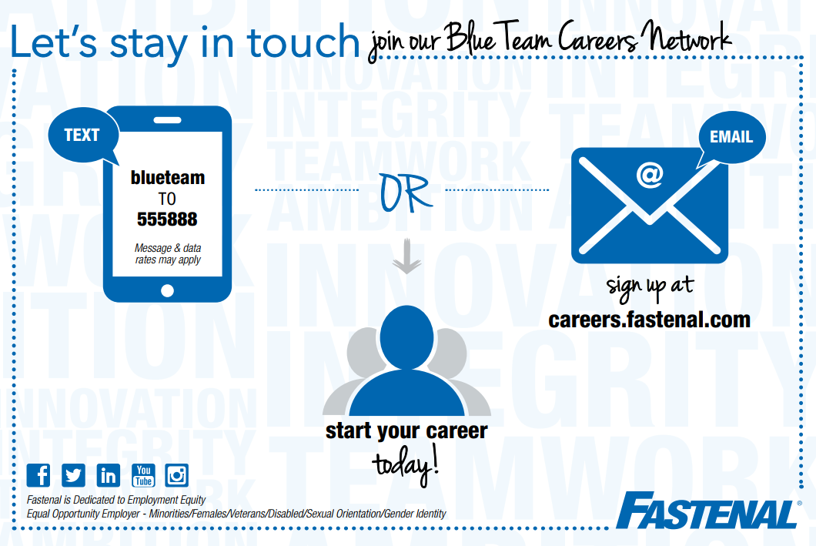

Please be sure to extend your gratitude to our conference sponsors!

Platinum/Speaker Sponsor
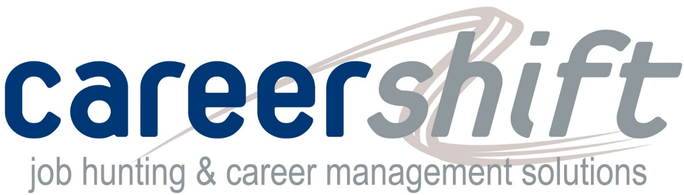

Silver Sponsors
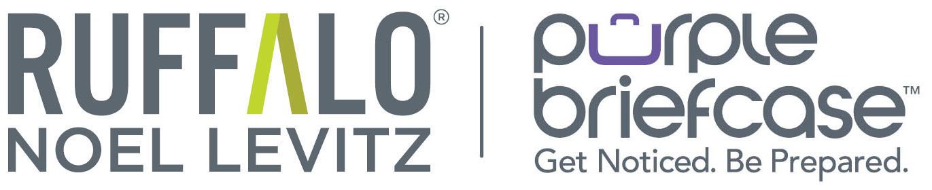

Bronze Sponsor

